Lab program 9 :
- Write a program to traverse a graph using BFS method
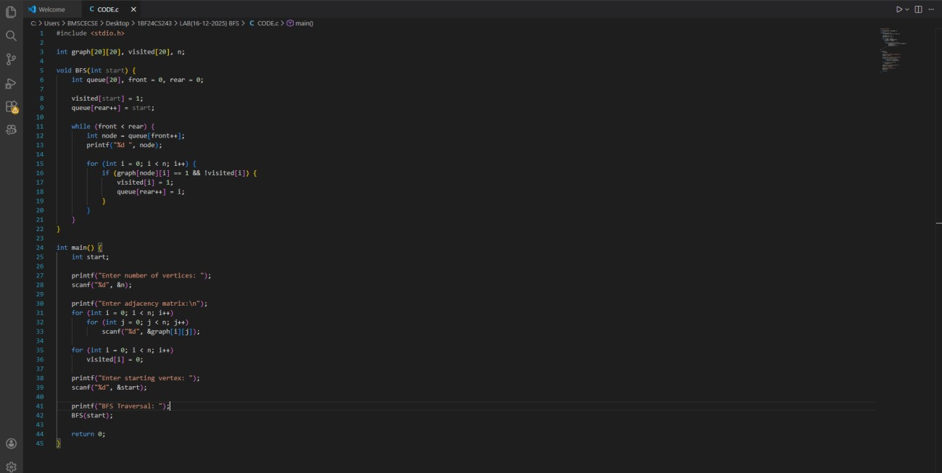

OUTPUT

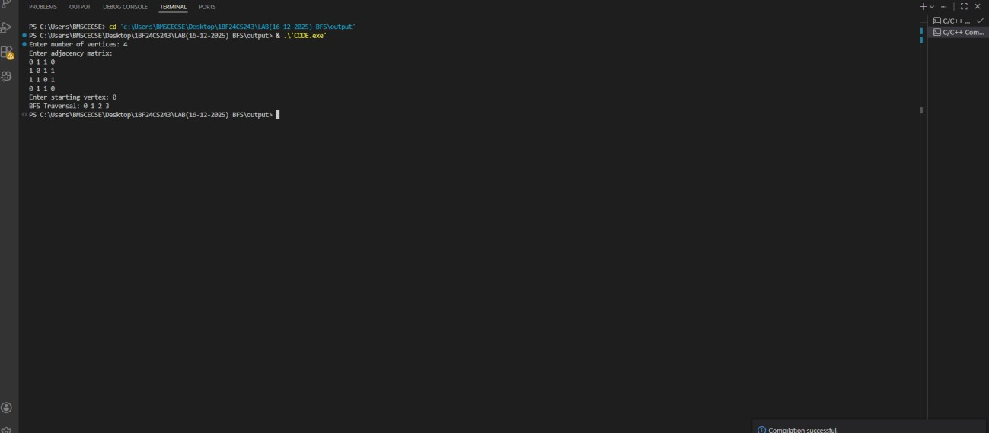

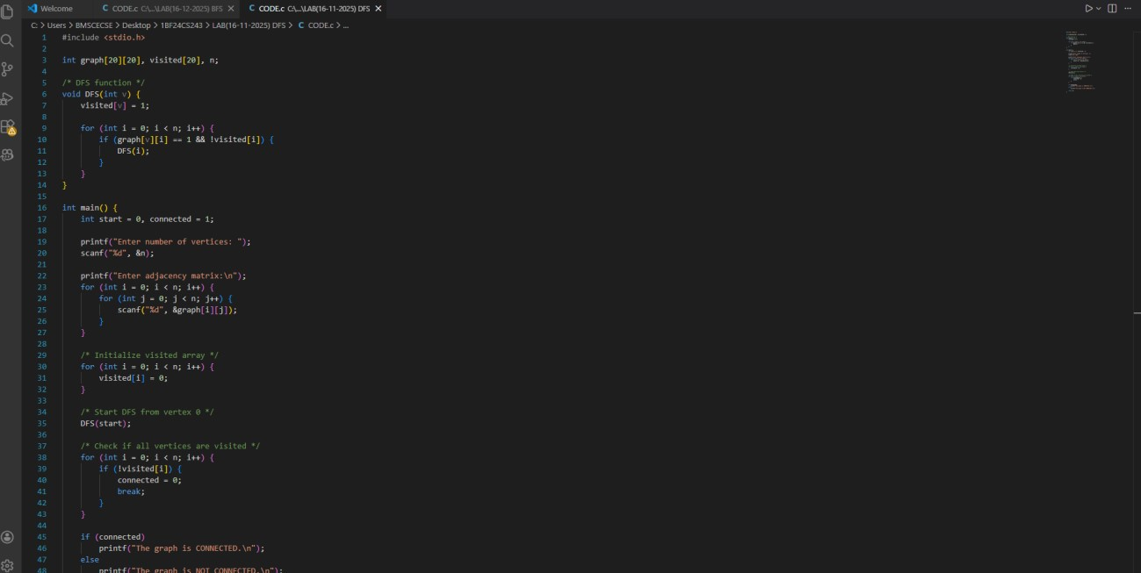
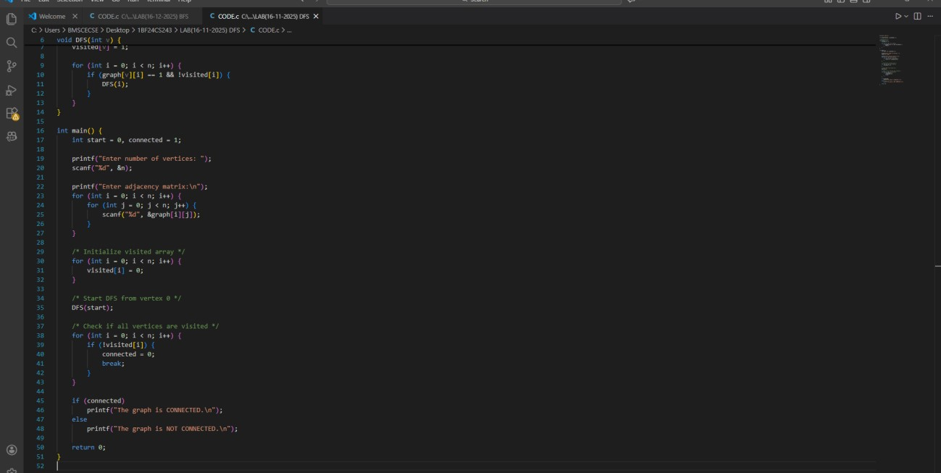
b) Write a program to check whether given graph is connected or not using DFS method.

OUTPUT

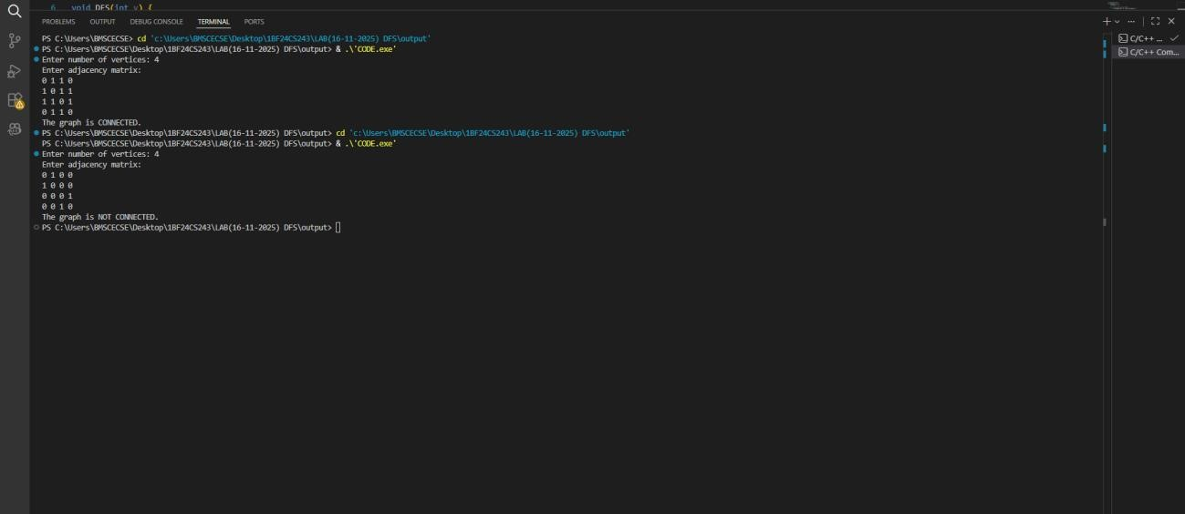

Lab program 10
Given a File of N employee records with a set K of Keys(4- digit) which uniquely determine the records in file F. Assume that file F is maintained in memory by a Hash Table (HT) of m memory locations with L as the set of memory addresses (2-digit) of locations in HT. Let the keys in K and addresses in L are integers. Design and develop a Program in C that uses Hash function H: K -> L as H(K)=K mod m (remainder method), and implement hashing technique to map a given key K to the address space L. Resolve the collision (if any) using linear probing.

#include <stdio.h>

#define MAX 20

int hashTable[MAX];
int m;

void insert(int key)
{
int index = key % m;

if (hashTable[index] == -1)
{
hashTable[index] = key;
}
else
{
int i = 1;
while (hashTable[(index + i) % m] != -1 )
{
i++;
}
hashTable[(index + i) % m] = key;
}
}

void display()
{
printf("\nHash Table:\n");
for (int i = 0; i < m; i++)
{
if (hashTable[i] != -1)
{
printf("Address %d: %d\n", i, hashTable[i]);
}
else
{
printf("Address %d: Empty\n", i);
}
}
}

int main()
{
int n, key;

printf("Enter size of hash table (m): ");
scanf("%d", &m);

printf("Enter number of employee records: ");
scanf("%d", &n);

for(int i = 0; i < m; i++)
hashTable[i] = -1;

printf("Enter %d employee keys (4-digit):\n", n);
for (int i = 0; i < n; i++)
{
scanf("%d", &key);
insert(key);
}

display();

return 0;
}

Output
